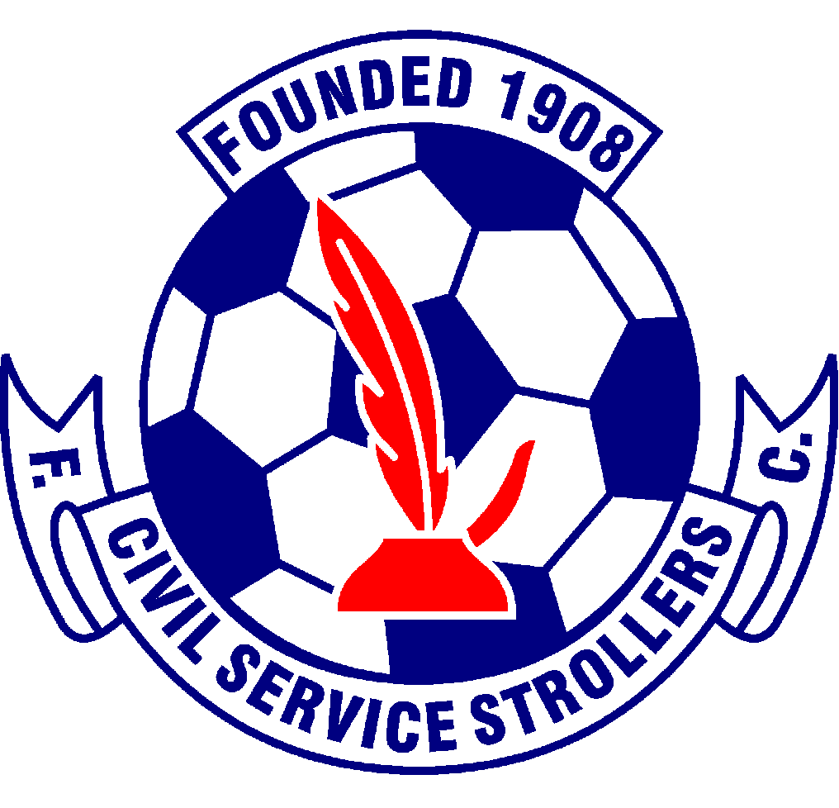

Civil Service Strollers Amateur Football Club

Code of Conduct for Coaches

Coaches are key to the establishment of ethics in football. Their concept of ethics and their attitude directly affects the behaviour of players under their supervision. Coaches are, therefore expected to pay particular care to the moral aspects of their conduct.

Coaches have to be aware that almost all of their everyday decisions and choices of actions, as well as strategic targets, have ethical implications.

It is natural that winning constitutes a basic concern for coaches. This code is not intended to conflict with that. However, the code calls for coaches to disassociate themselves from a “win at all costs” attitude.

Increased responsibility is requested from coaches involved in coaching young people. The health, safety, welfare and moral education of young people are a first priority, before achievement or the reputation of the club, coach or parent.

- Coaches must respect the rights, dignity and worth of every person and treat each equally within the context of the sport.
- Coaches must place the well being and safety of each player above all other considerations, including the development of performance.
- Coaches must adhere to all guidelines laid down by the governing body.
- Coaches must develop an appropriate working relationship with each player based on mutual trust and respect.
- Coaches must not exert undue influence to obtain personal benefit or reward.
- Coaches must encourage and guide players to accept responsibility for their own behaviour and performance.
- Coaches must ensure that the activities they direct or advocate are appropriate for the age, maturity, experience and ability of players.
- Coaches should, at the outset, clarify with players (and, where appropriate, parent) exactly what is expected of them and also what they are entitled to expect from their coach.
- Coaches must co-operate fully with other specialists (e.g. other coaches. Officials, sports scientists, doctors, physios) in the best interest of the player.
- Coaches must always promote the positive aspects of the sport (e.g. fair play) and never condone violations of the Laws of the Game, behaviour contrary to the spirit of the Laws of the Game or relevant rules and regulations or the use of prohibited substances or techniques.
- Coaches must consistently display high standards of behaviour and appearance.
- Coaches must not use or tolerate inappropriate language.
- Coaches must promote and encourage, particularly to young players, the importance of a healthy lifestyle and diet.
- Coaches must provide guidance and support to players on the dangers of drug abuse.
- Coaches must adhere to the terms of the Club’s Policy on Anti-Discrimination

Issue 1 – July 2014
Issue 2 – 07.06.2016
Issue 3 – 12.05.2017
Issue 4 – 21.02.2018
Issue 5 – 24/06/2021
Issue 6 – 06/06/2022 – KS
Issue 7 – 25/06/2023 – KS
Issue 8 – 31/07/2024 - KS

Gary Jardine
Malcolm Fielding

